Canon 20D Digital

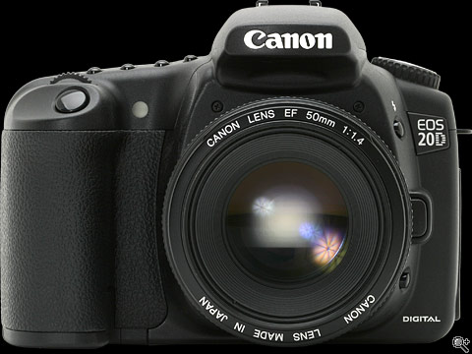
It's been four years and four months since they revealed the EOS D30, the first digital SLR which amateur photographers could really afford. So here we are, 52 months later with the latest incarnation of that original design, the eight megapixel EOS 20D. Not since February 2002 (the EOS D60) has Canon increased the resolution of this line of digital SLRs, in the EOS 20D we have a 1.9 million effective pixel increase, a new AF system, 50% faster continuous shooting and more than double the buffer space.
First impressions of the EOS 20D are good, it feels far less 'prosumer like' and instead feels more like a 'baby EOS-1D' (as described by one of our team). Gone are some of the annoyances of the EOS 10D, the 20D now switches on virtually instantly and focuses quickly, it feels very solid and yet weighs slightly less than the model it replaces. So far so good.

